Resource Packet:
Should the US have resorted to nuclear warfare to end World War II?

Directions: The following packet contains the resources you may use to help you prepare for the Socratic seminar. You will also have this resource packet to use as evidence in your essay. This is yours to write on and we recommend annotating it as you can have it with you during the seminar and essay writing.

Source 1
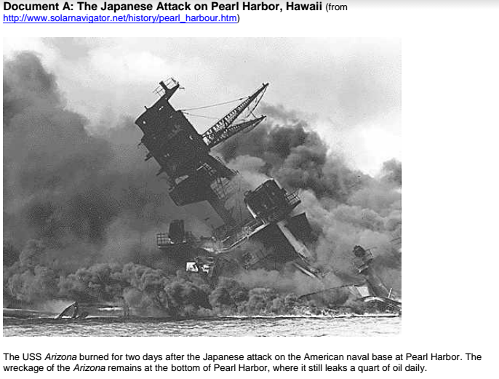
Source 2: Dwight Eisenhower’s view on dropping the atomic bomb

"In 1945 ... , Secretary of War Stimson visited my headquarters in Germany, [and] informed me that our government was preparing to drop an atomic bomb on Japan. I was one of those who felt that there were a number of cogent reasons to question the wisdom of such an act.... During his recitation of the relevant facts, I had been conscious of a feeling of depression and so I voiced to him my grave misgivings, first on the basis of my belief that Japan was already defeated and that
dropping the bomb was completely unnecessary, and second because I thought that our country should avoid shocking world opinion by the use of a weapon whose employment was, I thought, no longer mandatory as a measure to save American lives. It was my belief that Japan was, at that very moment, seeking some way to surrender with a minimum loss of 'face.' The Secretary was deeply perturbed by my attitude, almost angrily refuting the reasons I gave for my quick conclusions."
Source 3: Winston Churchill’s view on dropping the atomic bomb
“On July 17 world-shaking news had arrived. In the afternoon Stimson called at my abode and laid before me a sheet of paper on which was written, "Babies satisfactorily born." By his manner I saw something extraordinary had happened. "It means," he said," that the experiment in the New Mexican desert has come off. The atomic bomb is a reality." Although we had followed this dire quest with every scrap of information imparted to us, we had not been told beforehand, or at any rate I did not know, the date of the decisive trial. No responsible scientist would predict what would happen when the first fullscale atomic explosion was tried. Were these bombs useless or were they annihilating? Now we knew. The "babies" had been "satisfactorily born." No one could yet measure the immediate military consequences of the discovery, and no one has yet measured anything else about it.
Next morning a plane arrived with a full description of this tremendous even in the human history. Stimson brought me the report.... The President invited me to confer with him forthwith. He had
with him General Marshall and Admiral Leahy. Up to this moment we had shaped our ideas towards an assault upon the homeland of Japan by terrific air bombing and by the invasion of very large armies. We had contemplated the desperate resistance of the Japanese fighting to the death with Samurai devotion, not only in pitched battles, but in every cave and dug-out. I had in my mind the spectacle of Okinawa island, where many thousands of Japanese, rather than surrender, had drawn up in a line and destroyed themselves by hand-grenades after their leaders had solemnly performed the rite of harakiri . To quell the Japanese resistance man by man and conquer the country yard by yard might well require the loss of a million American lives and half that number of British --or more if we could get them there: for we were resolved to share the agony. Now all this nightmare picture had vanished. In its place was the vision --fair and bright indeed it seemed --of the end of the whole war in one or two violent shocks....
Moreover, we should not need the Russians. The end of the Japanese war no longer depended upon the pouring in of their armies for the final and perhaps protracted slaughter. We had no need to ask favours of them.... We seemed suddenly to have become possessed of a merciful abridgment of the slaughter in the East and a far happier prospect in Europe.... At any rate, there never was a moment's discussion as to whether the atomic bomb should be used or not....
The final decision now lay in the main with President Truman, who had the weapon; but I never doubted what it would be, nor have I ever doubted since that he was right. The historic fact remains, and must be judged in the after-time, that the decision whether or not to use the atomic bomb to compel the surrender of Japan was never even an issue. There was unanimous, automatic, unquestioned agreement around our table; nor did I ever hear the slightest suggestion that we should do otherwise.”

Source 4: An Internet Article

History of the Atomic - The Manhattan Project

"My God, what have we done?" - Robert Lewis co-pilot of the Enola Gay
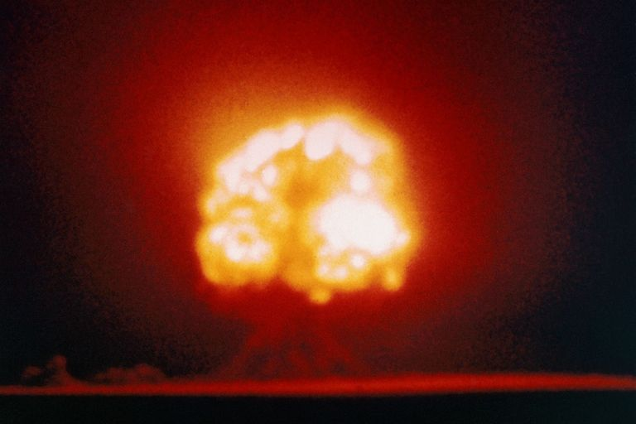
The first atomic bomb explodes at Alamogordo, New Mexico on July 16, 1945. © CORBIS / Corbis via Getty Images

Updated February 22, 2017
On August 2, 1939, just before the beginning of World War II, Albert Einstein wrote to then President Franklin D. Roosevelt. Einstein and several other scientists told Roosevelt of efforts in Nazi Germany to purify uranium-235, which could be used to build an atomic bomb. It was shortly thereafter that the United States Government began the serious undertaking known then only as "The Manhattan Project." Simply put, the Manhattan Project was committed to expediting research that would produce a viable atomic bomb.

Making Enriched Uranium
The most complicated issue to be addressed in making of an atomic bomb was the production of ample amounts of "enriched" uranium to sustain a chain reaction. At the time, uranium-235 was very hard to extract. In fact, the ratio of conversion from uranium ore to uranium metal is 500:1. Compounding this, the one part of uranium that is finally refined from the ore is over 99% uranium-238, which is practically useless for an atomic bomb. To make the task even more difficult, the useful U-235 and nearly useless U-238 are isotopes, nearly identical in their chemical makeup. No ordinary chemical extraction method could separate them; only mechanical methods could work.
A massive enrichment laboratory/plant was constructed at Oak Ridge, Tennessee. Harold Urey and his colleagues at Columbia University devised an extraction system that worked on the principle of gaseous diffusion, and Ernest Lawrence (inventor of the Cyclotron) at the University of California in Berkeley implemented a process involving magnetic separation of the two isotopes.
Next, a gas centrifuge was used to further separate the lighter U-235 from the heavier, non-fissionable U-238. Once all of these procedures had been completed, all that needed to be done was to put to the test the entire concept behind atomic fission ("splitting the atom," in layman's terms).

Robert Oppenheimer - Manhattan Project
Over the course of six years, from 1939 to 1945, more than $2 billion was spent during the history of the Manhattan Project.
The formulas for refining uranium and putting together a working atomic bomb were created and seen to their logical ends by some of the greatest minds of our time. Chief among the people who unleashed the power of the atom was Robert Oppenheimer, who oversaw the project from conception to completion.

Testing The Gadget aka Atomic Bomb
Finally, the day came when all at Los Alamos would find out if "The Gadget" (code-named as such during its development) was going to be the colossal dud of the century or perhaps an end to the war. It all came down to a fateful morning in midsummer, 1945.
At 5:29:45 (Mountain War Time) on July 16, 1945, in a white blaze that stretched from the basin of the Jemez Mountains in northern New Mexico to the still-dark skies, "The Gadget" ushered in the Atomic Age. The light of the explosion then turned orange as the atomic fireball began shooting upwards at 360 feet per second, reddening and pulsing as it cooled. The characteristic mushroom cloud of radioactive vapor materialized at 30,000 feet. Beneath the cloud, all that remained of the soil at the blast site were fragments of jade green radioactive glass created by the heat of the reaction.
The brilliant light from the detonation pierced the early morning skies with such intensity that residents from a faraway neighboring community would swear that the sun came up twice that day.
Even more astonishing is that a blind girl saw the flash 120 miles away.
Upon witnessing the explosion, its creators had mixed reactions. Isidor Rabi felt that the equilibrium in nature had been upset as if humankind had become a threat to the world it inhabited. Robert Oppenheimer, though ecstatic about the success of the project, quoted a remembered fragment from the Bhagavad Gita. "I am become Death," he said, "the destroyer of worlds." Ken Bainbridge, the test director, told Oppenheimer, "Now we're all sons of bitches."
After viewing the results several participants signed petitions against loosing the monster they had created, but their protests fell on deaf ears. The Jornada del Muerto of New Mexico would not be the last site on planet Earth to experience an atomic explosion.

Hiroshima
As many know, the atomic bomb has been used only twice in warfare. The first was at Hiroshima. A uranium bomb nicknamed "Little Boy" (despite weighing in at over four and a half tons) was dropped on Hiroshima August 6, 1945. The Aioi Bridge, one of 81 bridges connecting the seven-branched delta of the Ota River, was the target; ground zero was set at 1,980 feet.
At 0815 hours, the bomb was dropped from the Enola Gay. It missed by only 800 feet. At 0816 hours, in an instant, 66,000 people were killed and 69,000 injured by a 10-kiloton atomic explosion.
The area of total vaporization from the atomic bomb blast measured one half mile in diameter; total destruction one mile in diameter; severe blast damage as much as two miles in diameter. Within a diameter of two and a half miles, everything flammable burned. The remaining area of the blast zone was riddled with serious blazes that stretched out to the final edge at a little over three miles in diameter.

Nagasaki
On August 9, 1945, Nagasaki fell to the same treatment. This time a Plutonium bomb nicknamed "Fat Man" was dropped on the city. Though "Fat Man" missed its target by over a mile and a half, it still leveled nearly half the city. In a split second, Nagasaki's population dropped from 422,000 to 383,000. Over 25,000 people were injured.
Japan offered to surrender on August 10, 1945.
NOTE: Physicists who have studied these two atomic explosions estimate that the bombs utilized only 1/10th of 1 percent of their respective explosive capabilities.
Source 5: ABC News Article

Man Who Survived Hiroshima and Nagasaki Atomic Bombs Dies
The only person officially recognized as having been twice in the bull's eye of atomic bombs in Hiroshima and Nagasaki has died.
Tsutomu Yamaguchi, aged 93, passed away Monday. He had been hospitalized since November for stomach cancer.
"I'm very sorry that we have lost one of the very valuable witnesses of the atomic bomb experience," said Nagasaki Mayor Tomihisa Taue in a statement. "His harsh experience to be bombed twice has been made known to the world and his activities have made people aware of the foolishness of war and he also appealed for the elimination of nuclear weapons."
Yamaguchi, an engineer by trade, was on a business trip to Hiroshima on Aug. 6, 1945 when the world's first atomic bomb, code named Little Boy by the United States, left him temporarily blind and deaf, and with serious burns covering his body.
Three days later Yamaguchi had returned to his home in Nagasaki where less than 2 miles away the second bomb, dubbed Fat Man, was dropped.
The blasts caused Yamaguchi to lose hearing in his left ear, according to The Mainichi Daily News. He also suffered from acute leukemia, cataracts and other bomb-related illnesses in subsequent years. Atomic Bomb Survivors are defined by law as people who were within a specific radius of the bombings or who were exposed to radiation during the fallout.
Yamaguchi had been recognized as "hibakusha," translated as "explosion affected people," by the Japanese government.
There are over 200,000 officially recognized hibakusha in Japan, and they are reportedly entitled to a small monthly allowance from the government. Many still suffer from exposure to radiation.
In March 2009 - nearly 64 years after the bombings – the Japanese government certified that Yamaguchi was indeed targeted twice.
"My double radiation exposure is now an official government record," Yamaguchi said last year as quoted by The Mainichi Daily News. "It can tell the younger generation the horrifying history of the atomic bombings even after I die."
Over the last few years Yamaguchi shared his personal accounts publicly. He spoke at the United Nations, wrote books and appeared in the documentary "Twice Bombed, Twice Survived: The Doubly Atomic Bombed of Hiroshima and Nagasaki" by filmmaker Hideo Nakamura.

Study Shows More People Twice Targeted
On the 60th anniversary of the bombings, the Hiroshima National Peace Memorial Hall for the Atomic Bomb Victims conducted a study, according to The Mainichi Daily News, of over 100,000 accounts of the bombings and found nine people believed to be also twice targeted.
Tsutomu Yamaguchi remains the only double A-bomb survivor officially recognized.

Source 6: A Political Cartoon
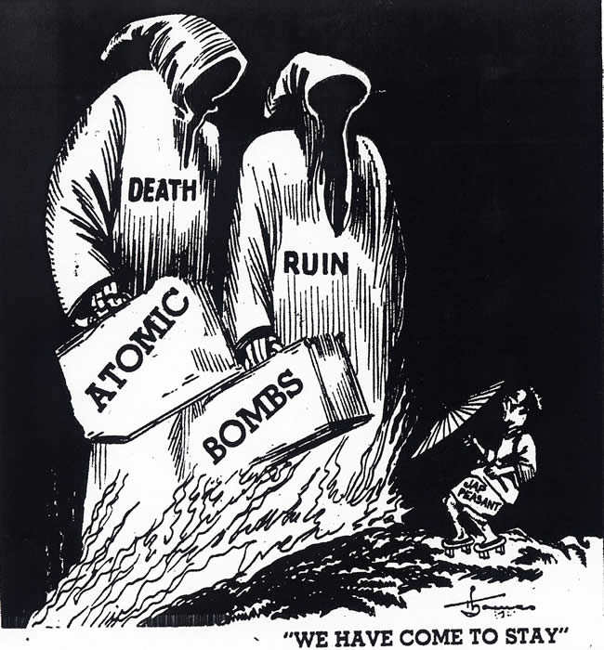

Source 7
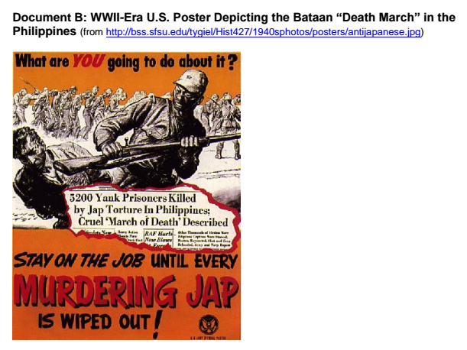

Source 8: Japanese kamikaze attack on US ship
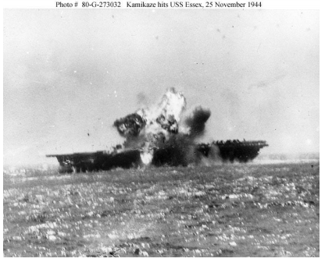

Source 9
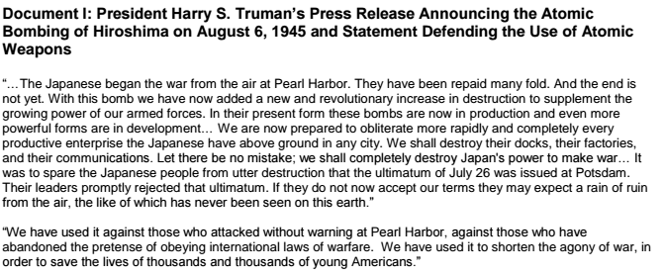

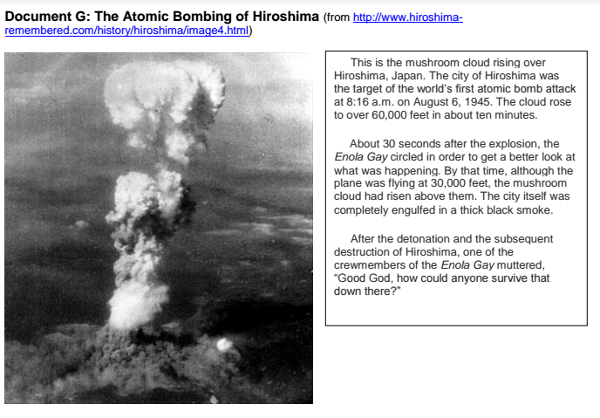
Source 10

Source 11
